SWE4303 Computing Infrastructure
Week 6 | Session 2 Lab Handout
Security Reasoning Lab: Threat-to-Control Mapping for a Given Infrastructure Brief
Lab positioning note: This lab uses infrastructure scenarios, network diagrams and Packet Tracer-style evidence to support security reasoning. It does not require new Cisco security configuration. The focus is on identifying exposed conditions, selecting suitable baseline controls, and explaining evidence and limitations clearly.

Assessment preparation note: This lab supports Assessment 1 by helping you prepare a clearer security considerations section and stronger validation/evaluation wording. Do not copy the scenario or model wording directly into your assessment. Use the same reasoning pattern with your own chosen business context, personalised network design and evidence.
Purpose of this lab
This lab helps you move from Week 6 security concepts into practical infrastructure reasoning. You will analyse a small enterprise scenario, identify exposed conditions or vulnerabilities, connect them to threat categories and CIA concerns, select suitable baseline controls, and explain what evidence could support your claims.
The purpose is not to become a cybersecurity specialist or to configure advanced security tools. The purpose is to produce clear, defensible security reasoning that can support an infrastructure design report.
What you should be able to do by the end
- identify key users, services, devices and access boundaries in a small enterprise infrastructure scenario
- describe exposed conditions or vulnerabilities in practical infrastructure terms
- map exposed conditions to CIA concerns and baseline threat categories
- select suitable baseline controls that respond to specific concerns
- identify what evidence could support a security claim
- explain what evidence cannot prove
- write a short Assessment 1-style security justification paragraph
Software and resources
- this lab handout
- the Week 6 lecture slides
- a pen, notebook or digital document for completing tables
- access to your existing Packet Tracer work or screenshots if you want to relate the activity to your own Assessment 1 design
- no new Packet Tracer configuration is required for this lab
You may refer to Packet Tracer-style evidence such as network diagrams, connectivity tests, service-access screenshots or configuration screenshots, but you are not required to build a new topology in this lab.
Before you start
Remember the Week 6 reasoning pattern:
Key pattern: asset/service -> exposed condition or vulnerability -> threat category -> CIA concern -> suitable baseline control -> evidence -> limitation

Avoid vague claims such as:
The network will be secure because security will be added.
Aim for specific reasoning such as:
Guest devices should not have unrestricted access to the staff intranet because this exposes an internal service to less-trusted users. A suitable control is to separate guest and staff access and apply filtering at the boundary.
Part 0 — Understand the security reasoning brief
A small training centre operates across two internal areas: an Administration area and a Teaching area. The centre uses staff devices, guest Wi-Fi, an internal staff intranet server, DNS and DHCP services, and remote administration for network devices.
The infrastructure appears to work, but the organisation now needs a clearer baseline security position. The design must explain what needs protection, what could go wrong, which controls are suitable, and what evidence could support the claims.
Business needs
The infrastructure must support:
- staff access to internal services
- guest Wi-Fi access
- an internal staff intranet
- DNS and DHCP services
- remote administration
- basic protection of service data, credentials and configuration
- reasonable availability and recovery thinking

Evidence pack
Use the evidence below as the starting point for your reasoning. The evidence is deliberately limited. Your job is to decide what it supports, what it does not prove, and which controls would be suitable.
Evidence item 1 — Network scenario diagram
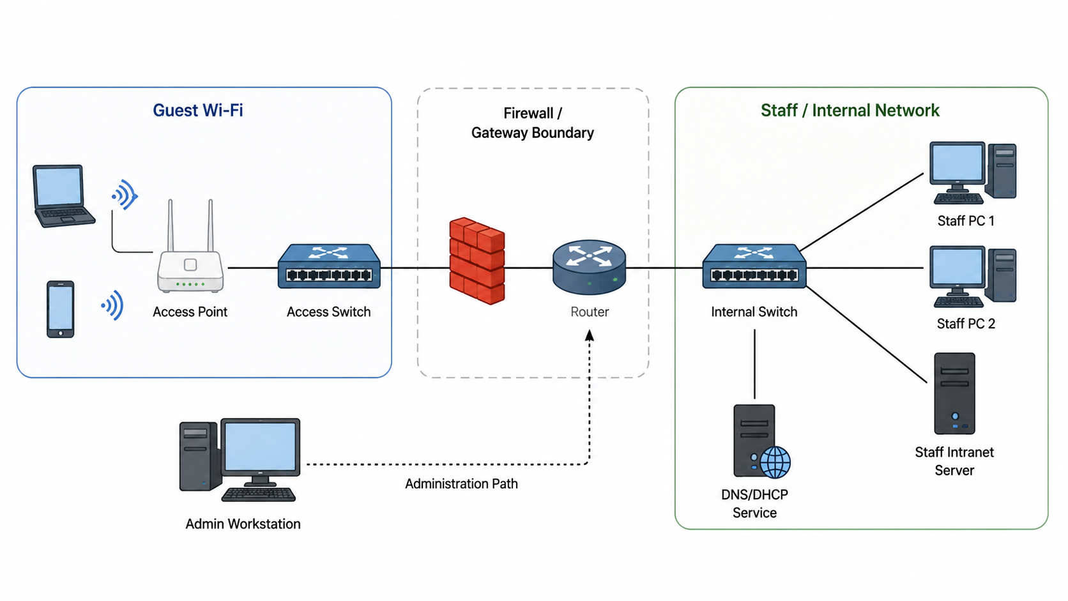
Figure 1. Small training centre security review scenario.
Evidence item 2 — Observed behaviours
Observation | What was seen
Guest laptop to staff intranet | Guest laptop can reach the staff intranet login page.
Staff PC to intranet | Staff PC can reach the intranet service.
Admin PC to network device | Remote administration is available.
Client devices | DNS and DHCP are used for normal network access.
Backup/recovery | No clear backup or recovery evidence is shown.
Monitoring/logging | No clear monitoring or logging evidence is shown.

Evidence item 3 — Notes from the review
- Some access boundaries are unclear.
- It is not clear whether guest users should reach staff services.
- It is not clear whether administration traffic is protected.
- Some services may be reachable from more network areas than necessary.
- No evidence is provided for backup, recovery, monitoring or logging.
- Device update and support status is not stated.

Part 1 — Identify assets, services, users and boundaries
Security reasoning starts by identifying what exists in the scenario. Complete the table below by identifying the main users, services, devices, data/configuration items and access boundaries.
Category | Examples from the scenario
Users
Services
Devices
Data or configuration
Access boundaries

Check your understanding
Why is it important to identify assets and services before choosing controls?
Answer: _______________________________________________________________________
Why should guest users and staff users not automatically have the same access?
Answer: _______________________________________________________________________
Which parts of the scenario involve configuration trust?
Answer: _______________________________________________________________________
Part 2 — Identify exposed conditions or vulnerabilities
A vulnerability is an exposed condition or weakness that makes a security concern more likely or more damaging. In this lab, you do not need to perform a professional vulnerability assessment. You only need to identify practical weaknesses in the scenario and explain why they matter.
Examples of exposed conditions
- guest Wi-Fi can reach the staff intranet
- remote administration uses an unsuitable or unprotected method
- administrator access is shared or poorly controlled
- unnecessary services are enabled
- devices or operating systems may be outdated
- updates or patching are not clearly managed
- DNS/DHCP settings are weakly controlled
- no clear backup or recovery plan is shown
- no clear monitoring or logging evidence is shown
- equipment or console access is physically exposed

Complete the table with at least four exposed conditions from the scenario or review notes.
Exposed condition / vulnerability | Why it matters

Part 3 — Map exposed conditions to CIA and threat categories
Choose at least four exposed conditions from Part 2. For each one, identify the threat category, CIA concern and possible impact.
Threat category reminder: unauthorised access; credential exposure; misconfiguration; service disruption; data exposure or loss; privilege misuse; physical or local access risk.

Asset or service | Exposed condition / vulnerability | Threat category | CIA concern | Possible impact
Staff intranet
Remote administration
DNS/DHCP
Business data or files
Check your understanding
Is “guest reaches staff intranet” a vulnerability, a threat category, or an impact?
Answer: _______________________________________________________________________
Why might one exposed condition affect more than one CIA principle?
Answer: _______________________________________________________________________
Why is security risk too vague as an answer?
Answer: _______________________________________________________________________

Part 4 — Select suitable baseline controls
For each concern, select a suitable baseline control. Your control must match the concern. Do not simply write “add security” or “use a firewall” without explaining why the control fits.
Baseline control reminder: possible controls include least privilege, separation of guest/staff/management access, protected protocols such as SSH/HTTPS/SFTP, traffic filtering at internal boundaries, named administrator accounts, password and account rules, disabling unnecessary services, update and patching practice, backup and recovery planning, logging and monitoring, and controlled physical/local access.

Concern | Suitable baseline control | Why this control fits
Guest device can reach staff intranet
Remote administration may be unprotected
Administrator access is too broad or shared
No clear backup or recovery evidence
No clear monitoring or logging evidence

Control-check questions
Does the control actually respond to the concern?
Answer: _______________________________________________________________________
Is the control realistic for a small enterprise design?
Answer: _______________________________________________________________________
Can you explain the control without overclaiming that it solves all security problems?
Answer: _______________________________________________________________________

Part 5 — Evidence and limitation mapping
Evidence supports a specific claim. It does not prove everything. For each security claim, identify what evidence could support it and what the evidence cannot prove.
Evidence examples
- labelled network diagram
- addressing or segmentation table
- Packet Tracer reachability test
- service access test
- SSH configuration or access screenshot
- filtering or access-control evidence
- written backup/recovery plan
- logging or monitoring screenshot
- short technical interpretation
Limitation examples
- evidence does not prove that all attacks are prevented
- evidence does not prove that all users are authorised correctly
- evidence does not prove that the whole system is resilient
- evidence does not prove that every configuration is production-ready
- evidence does not prove that controls will be maintained correctly
- Packet Tracer evidence supports design logic but does not prove full real-world security

Security claim | Evidence that could support it | What the evidence cannot prove
Guest access is separated from staff services
Remote administration is protected
DNS/DHCP service availability is considered
Backup or recovery has been considered
Monitoring or logging has been considered

Part 6 — Write a short security justification
Choose one concern from your mapping table and write one short security justification paragraph. Your paragraph should link the concern, CIA principle, exposed condition, control, evidence and limitation.
Writing frame
The main concern is ________________________________________________.
This affects _________________________________ because _______________________________.
The exposed condition is ________________________________________________.
A suitable baseline control is ________________________________________________.
This control is appropriate because ________________________________________________.
Evidence that could support this claim includes ____________________________________________.
A remaining limitation is ________________________________________________.
Worked example
Guest devices should not have unrestricted access to the staff intranet. The exposed condition is that a less-trusted guest segment can reach an internal staff service. This creates an unauthorised access concern affecting confidentiality and possibly integrity. A suitable baseline control is to separate guest and staff traffic and apply filtering at the internal boundary. Evidence could include a labelled network diagram and controlled reachability tests showing that staff devices can access the intranet while guest devices cannot. This evidence supports the design logic, but it does not prove full real-world security or that all user permissions are correctly maintained.
Your paragraph
__________________________________________________________________________________
__________________________________________________________________________________
__________________________________________________________________________________
__________________________________________________________________________________
__________________________________________________________________________________
Part 7 — Review and improve your wording
Rewrite the weak statements below so that they become specific, evidence-aware and defensible.
Every improved statement should make clear what is being protected, what concern is being reduced, what control is being used, and what evidence or limitation should be considered where relevant.
Weak statement | Improved statement
The network will be secure.
A firewall will protect the system.
SSH is more secure.
Backups are important.
Guests should be blocked.

Part 8 — Final reflection and assessment readiness
Answer the questions below before you finish the lab.
Which exposed condition was easiest to analyse?
Answer: _______________________________________________________________________
Which control was hardest to justify?
Answer: _______________________________________________________________________
What evidence would be most useful for Assessment 1?
Answer: _______________________________________________________________________
What is one limitation you should avoid overclaiming?
Answer: _______________________________________________________________________
What is one improvement you can make to your own Assessment 1 security section?
Answer: _______________________________________________________________________

Evidence checklist
Before you finish, make sure you have completed the following evidence. Your tutor may ask to see your completed tables or security justification paragraph.
Evidence item | Completed?
Asset, service, user and access-boundary table completed | [ ]
Exposed condition / vulnerability table completed | [ ]
CIA and threat-category mapping table completed | [ ]
Baseline control mapping table completed | [ ]
Evidence and limitation table completed | [ ]
At least one Assessment 1-style security justification paragraph written | [ ]
Weak security statements improved using specific, evidence-aware wording | [ ]
Final reflection questions completed | [ ]
If you get stuck
Work through the reasoning in this order:
- Start with the asset or service. What are you trying to protect?
- Identify the exposed condition. What weakness, open access pattern or missing evidence is visible?
- Decide what could go wrong. Is it unauthorised access, credential exposure, misconfiguration, service disruption, data exposure or loss, privilege misuse, or local access risk?
- Link the concern to CIA. Does it mainly affect confidentiality, integrity, availability, or more than one?
- Choose a control that matches the concern. Do not start with "add a firewall" unless you can explain exactly what traffic or access it controls.
- Identify evidence. What diagram, table, test, screenshot or written explanation could support the claim?
- State the limitation. What does the evidence not prove?
Do not change the concern halfway through the table. Complete one reasoning chain first, then move to another one.
Key idea from this lab
A security control is only defensible when it responds to a specific concern. Strong infrastructure security reasoning identifies what is exposed, explains why it matters, selects a suitable baseline control, and states what evidence supports the claim. Evidence is useful, but it does not prove complete real-world security.
Consolidate and look ahead
After the lab, complete the Week 6 quiz on security principles, threat categories and baseline mitigation.
Self-study: produce a brief threat-to-control mapping for a given infrastructure scenario.
Keep your completed tables and justification paragraph because the same reasoning pattern can help you prepare the Security considerations and Validation/evaluation sections of Assessment 1.
Next week is Consolidation Week, focusing on Assessment 1 design justification and validation readiness.

